In-Class Test Practice Lab – Rip v2

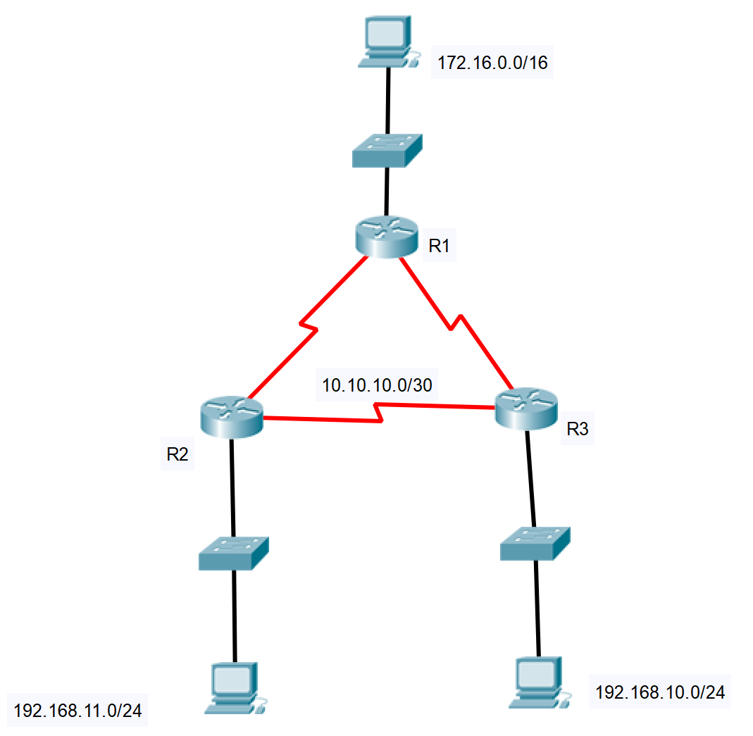

**Instructions**

This is a practice lab to help you prepare for the in-class test. Repeat this lab as many times as you can. Next week we will do this under a time constraint.

Each PC has the network address shown against it.

The routers are all on the 10.10.10.0/30, so this address will need subnetting and the correct IP addresses allocating to each subnet.

**Task**

* Create the above topology and configure using RIPv2. The IP addressing is given below. Note that the IP addresses are network addresses so you will need to subnet where appropriate.
* Ensure that RIPv2 has propagated across the network using the commands in last weeks lab.
* Use Ping and Tracert to check connectivity.
* Make sure you can configure all the basic configuration settings – passwords, console, telnet, message of the day and router names.
* Once the lab is complete and working add a Lo0 to R3 with the address of 209.165.201.45/32.
* Create a static default route to this IP address.